**7.1 The Genetic Code\***

* Central Dogma: DNA → RNA → Protein

Types of RNA

* mRNA
  + Carries the message from DNA in the nucleus via transcription of the gene; it travels into the cytoplasm to be translated
  + Monocistronic in eukaryotes; polycistronic in prokaryotes
* tRNA
  + Brings in amino acid and recognizes the codon on mRNA using its anticodon
  + Considered charged if amino acid is attached
* rRNA
  + Synthesized in the nucleolus
  + Many function as ribozymes (found in ribosomes), which catalyze the formation of peptide bonds

Codons

1. Initiation (start) codon: AUG
2. Termination (stop) codon: UAA, UGA, UAG

Mutations

* Redundancy and wobble (third base in the codon) allows mutations to occur without effects in the protein
* Point mutations can cause:
  + Silent mutation: no effect
  + Nonsense mutation: premature stop codon
  + Missense mutation: a codon that codes for a different amino acid
* Frameshift mutation result from nucleotide addition or deletion, and **change the reading frame of subsequent codons**

**7.2 Transcription\***

Mechanism of Transcription

1. Helicase unwinds the DNA double helix
2. RNA polymerase II binds to the TATA box within the promoter region of the gene (25 bp upstream from first transcribed base)
3. hnRNA is synthesized from the DNA template (antisense) strand

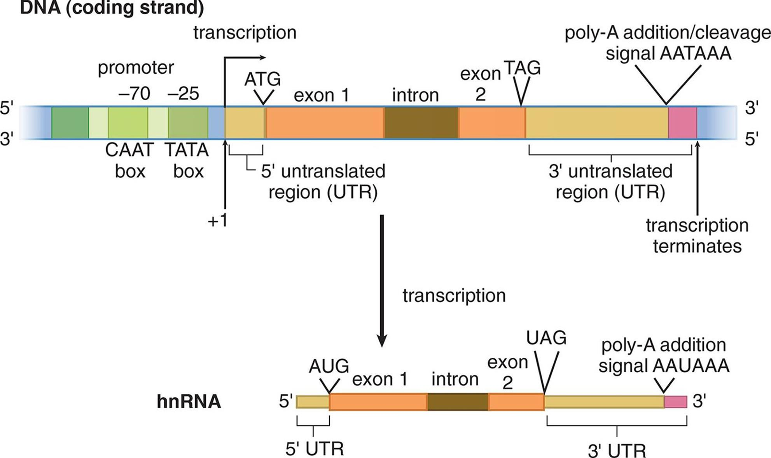

Posttranscriptional Processing

1. 5’ Cap
   1. Recognized by the ribosome as the binding site
   2. Protects the mRNA from degradation in the cytoplasm
2. 3’ Poly-A tail
   1. The longer the poly-A tail, the more time the mRNA will be able to survive before being digested in the cytoplasm
   2. Assists with export of the mature mRNA from the nucleus
3. Splicing: Introns and Exons
   1. Done by snRNA and snRNPs in the spliceosome
   2. Introns are removed in a lariat (lasso-shaped) structure, and exons are ligated together
4. Alternative Splicing
   1. An organism (eukaryote) can make many more different proteins from a limited number of genes

**7.3 Translation\***

The Ribosome

1. Prokaryotic 70S ribosome = 50S subunit + 30S subunit
2. Eukaryotic 80S ribosome = 60S subunit + 40S subunit

Mechanism of Translation

1. Initiation → binding
2. Elongation → APE
3. Termination → stop codon in A site

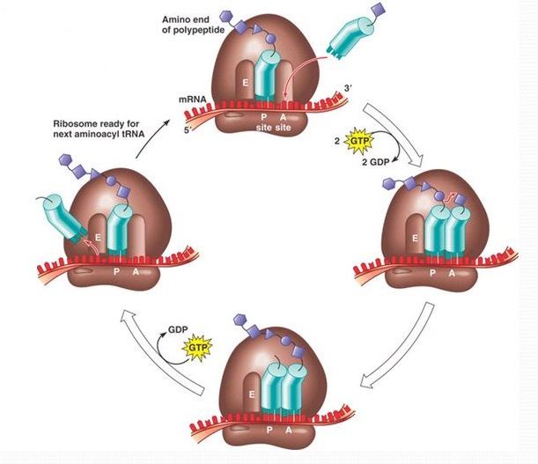

Posttranslational Processing

1. Folding by chaperones
2. Formation of quaternary structure
3. Cleavage of proteins or signal sequences
4. Covalent addition of other biomolecules (phosphorylation, carboxylation, glycosylation, prenylation)

**7.4 Control of Gene Expression in Prokaryotes\***

Operon Structure

* Operon = a cluster of genes transcribed as a single mRNA

Inducible Systems

* E.g. *lac* operon
* Bonded to a repressor under normal conditions; they can be turned on by an inducer pulling the repressor from the operator site

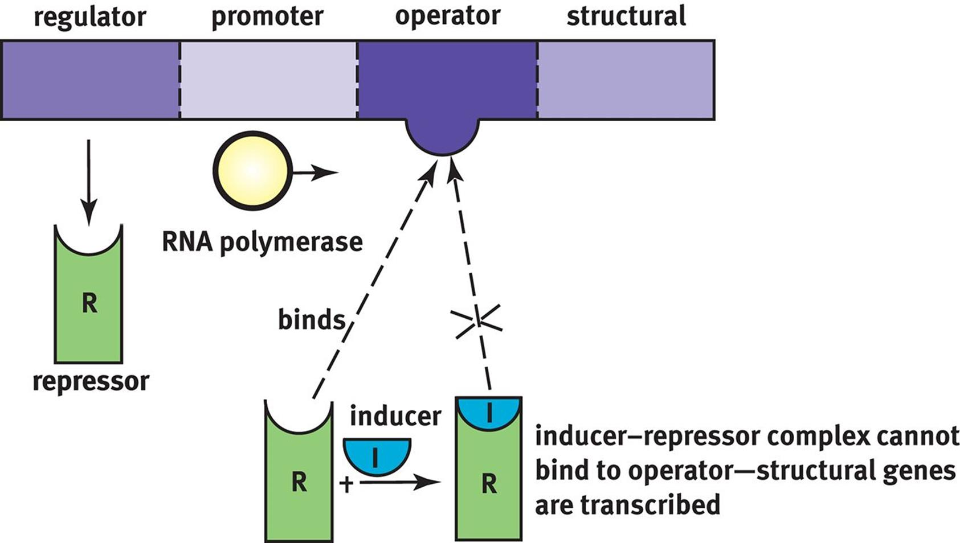

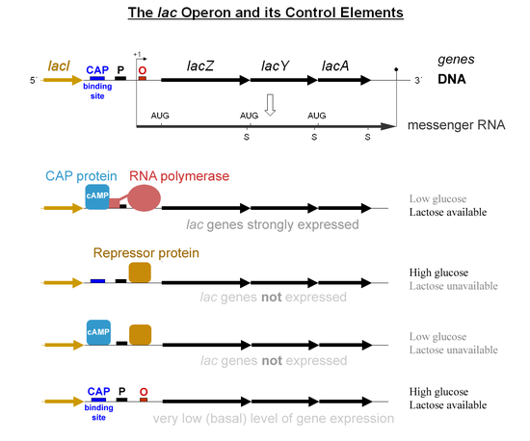

(allolactose is the inducer which will bind to the *lac* repressor, when lactose is available → increases transcription to break down lactose)

(low glucose → high cAMP → more cAMP binds to CAP, increasing transcription levels)

Repressible Systems

* E.g. *trp* operon
* Transcribed under normal conditions; they can be turned off by a corepressor coupling with the repressor and the binding of this complex to the operator site

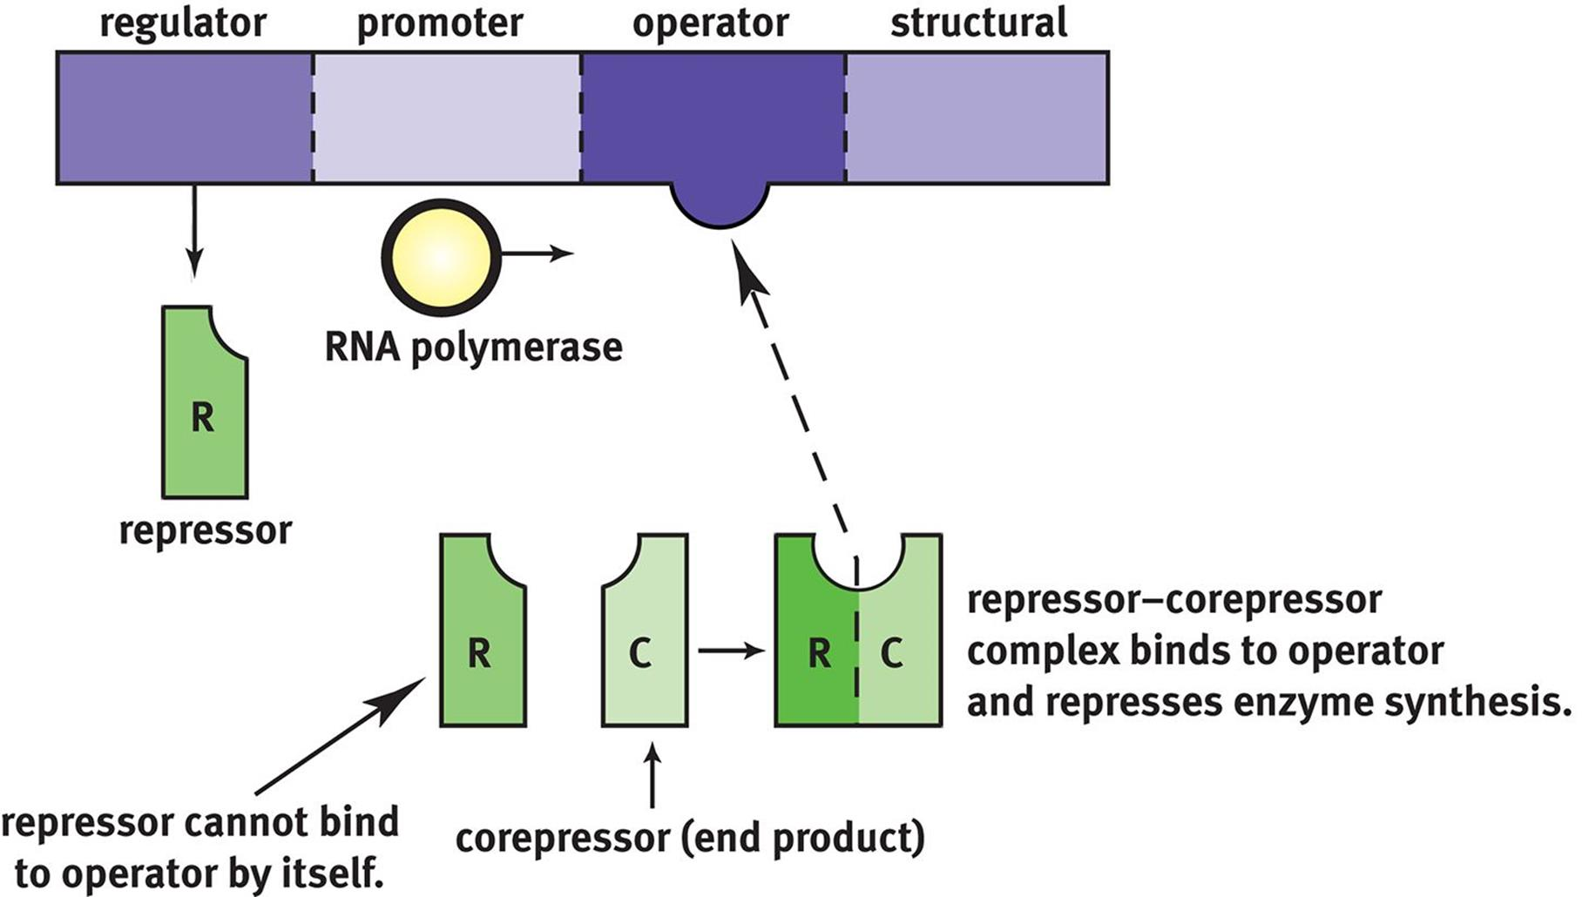

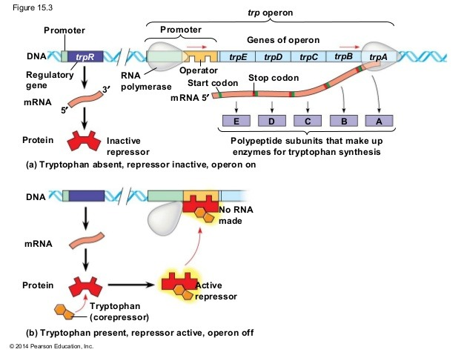

(Tryptophan acts as the corepressor)

**7.5 Control of Gene Expression in Eukaryotes\***

Transcription Factors

* Search for promoter and enhancer regions in the DNA
  + DNA binding domain
  + Activation domain (allows for the binding of several transcription factors and other important regulatory proteins e.g. RNA polymerase)

Gene Amplification

1. Enhancer
2. Gene duplication

Regulation of Chromatin Structure

1. Histone Acetylation
   1. Decreases the positive charge on lysine residues → weakens the interaction of histones with DNA → increases accessibility (thus increases transcription)

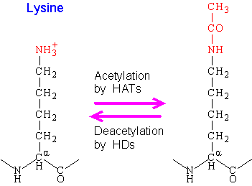

1. DNA Methylation
   1. Adds methyl groups to cytosine and adenine nucleotides → gene silencing → decreases accessibility (thus decreases transcription)